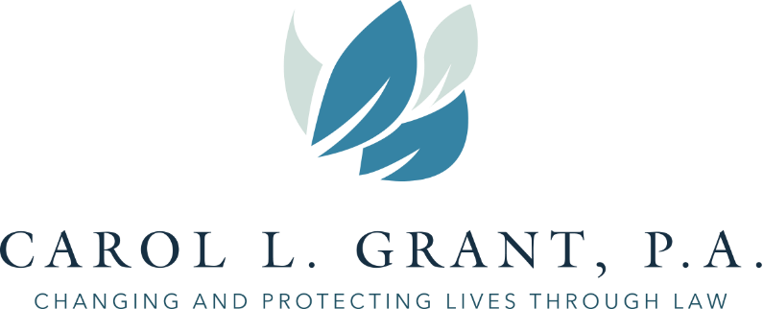
4801 S. UNIVERSITY DRIVE, SUITE 264/265 DAVIE, FLORIDA 33328
TELEPHONE (954) 404-8274
E-MAIL: carol@carolgrantlaw.com – WEBSITE: carolgrantlaw.com

ESTATE PLANNING HIDE AND SEEEK

ESTATE PLANNING LEGAL DOCUMENTS: SECURITIES:
_____REVOCABLE LIVING TRUST AND/OR IRREVOCABLE TRUST _____INVESTMENT SECURITIES
_____LAST WILL AND TESTAMENT _____BROKERAGE ACCOUNT
_____CERTIFICATION OF TRUST _____STOCK CERTIFICATES
_____SPECIAL GIFT MEMORANDUM _____BONDS
_____DURABLE POWER OF ATTORNEY _____ANNUITY CONTRACTS
_____HEALTH CARE SURROGATE DESIGNATION _____STOCK-PLAN OPTIONS
_____ANATOMICAL GIFT DECLARATION
_____ASSIGNMENT OF TANGIBLE PROPERTY
_____CEMETERY PLOT DEED
_____MEMORIAL INSTRUCTIONS BUSINESS PAPERS:
_____EMPLOYMENT CONTRACTS
REAL ESTATE: ____PARTNERSHIP AGREEMENTS
_____DEEDS TO REAL ESTATE _____LLC/CORPORATION DOCS
_____TITLE INSURANCE _____LEASES
_____RENTAL PROPERTY RECORDS _____BILLS OF SALE
_____NOTES & LOAN AGREEMNTS
_____MORTGAGES

PERSONAL EFFECTS AND OTHER ASSETS:
_____CAR TITLES
_____BOAT/PLANE TITLES
_____TENANCY AGREEMENT OR COMMUNITY PROPERTY AGREEMENT
_____LIST OF DIGITAL ASSETS
_____” DIGITAL ASSETS” USERNAMES & PASSWORDS CASH:
_____LIST OF INSURANCE POLICIES _____CHECKBOOKS
_____MARRIAGE CERTIFICATE _____SAVINGS PASSBOOK
_____DIVORCE/SEPARATION PAPERS _____CREDIT CARDS
_____BIRTH CERTIFICATES _____CDs
_____PASSPORTS/CITIZENSHIP PAPERS _____BANK INVESTMENTS
_____MILITARY PAPERS _____CANCELED CHECKS
_____LIST OF FRIENDS & RELATIVES
_____LIST OF ADVISORS
TAX RECORDS:
RETIREMENT PLANS: _____INCOME TAX RETURN
_____PENSION PLAN _____GIFT TAX RETURN
_____PROFIT SHARING PLAN/401(k)/403(b)
_____SIMPLE IRA OR IRA

